CS 255 System Design Document Template

UML Diagrams

UML Use Case Diagram
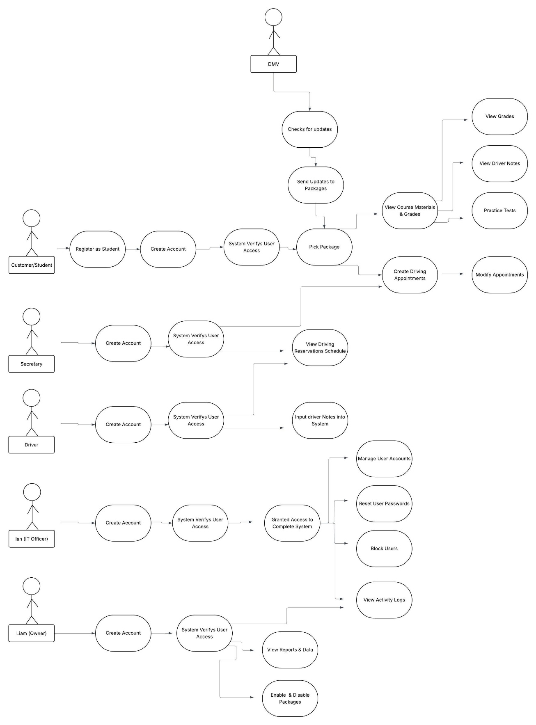

UML Activity Diagrams
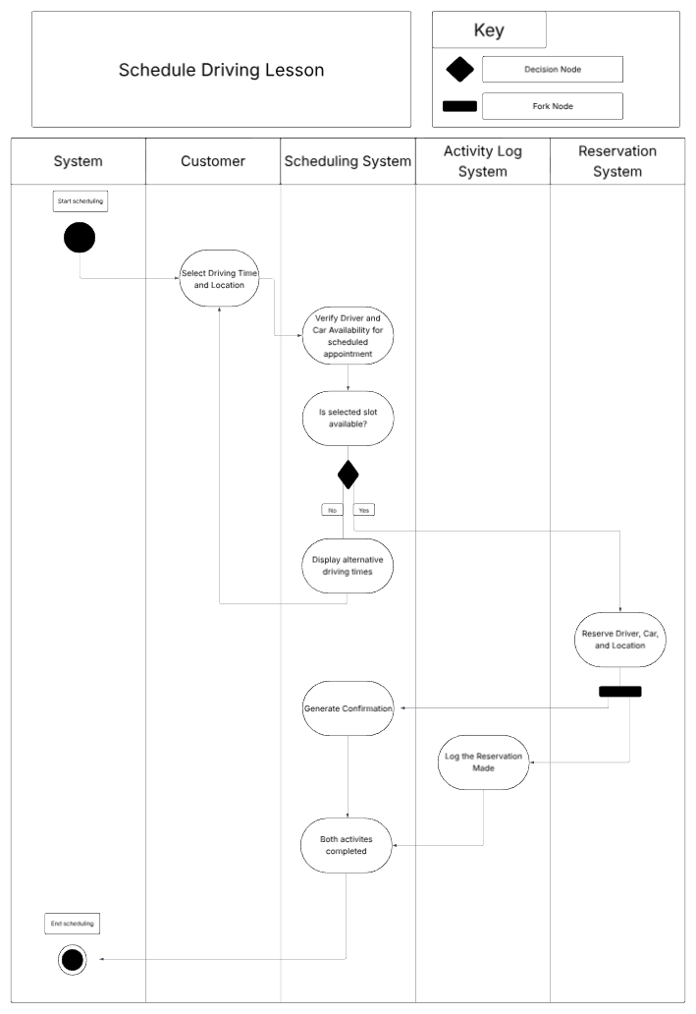

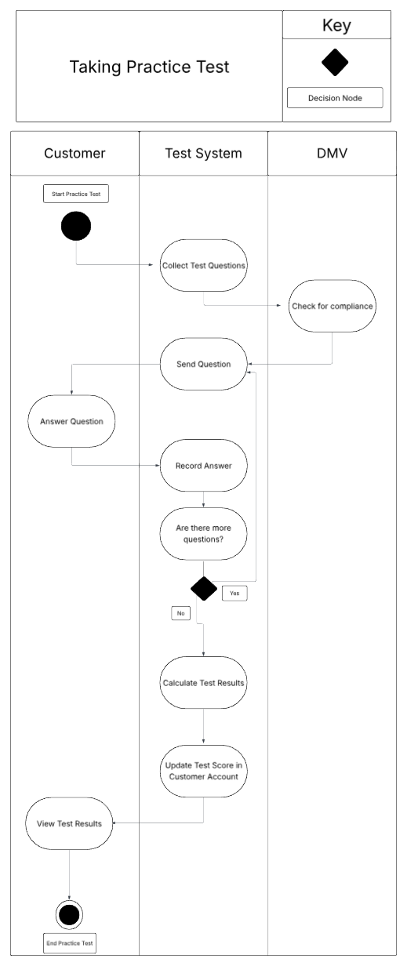

UML Sequence Diagram
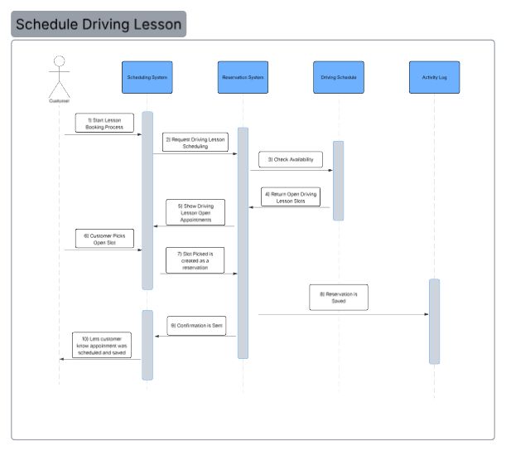

UML Class Diagram

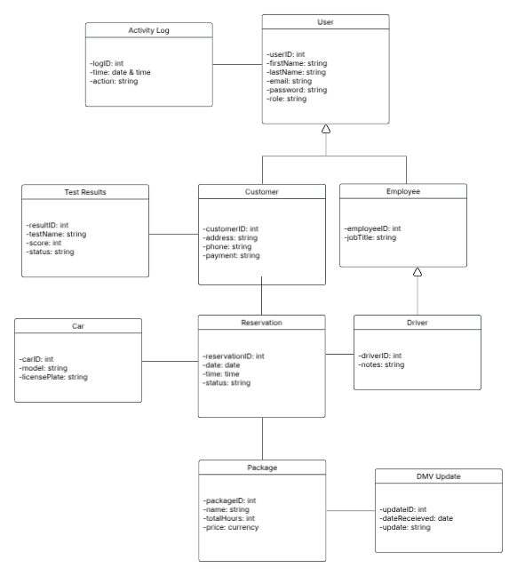

Technical Requirements

The software requirements need to support data modeling and workflow logic that was displayed in the diagrams above. The operating system needs to be available via a windows server for staff and a web-based browser for customers. A database management system is required to manage all the different classes. For the scheduling system a backend framework logic needs to be in place to handle reservations. Last for the software requirements are external integrations to connect to the DMV to heck for updates.
The hardware and infrastructure need to be online 99% of the time to handle all the customers online and staff working on the system. A cloud-based server is needed for hosting all data so work can be done offline. The scheduling and reservation systems need to be hosted on a web server. High-speed internet is a necessity if we want our system to be active as much as possible. For security of the system, we will want firewalls and load balancers to handle multiple users.
We want a tool that can handle role access that Ian is wanting to implement. This tool will allow Ian to reset other users’ passwords and block users. An automated log system will help capture every reservation made and show the user and time when it was made. To make sure the practice test logic is working we would use an automated testing tool.

